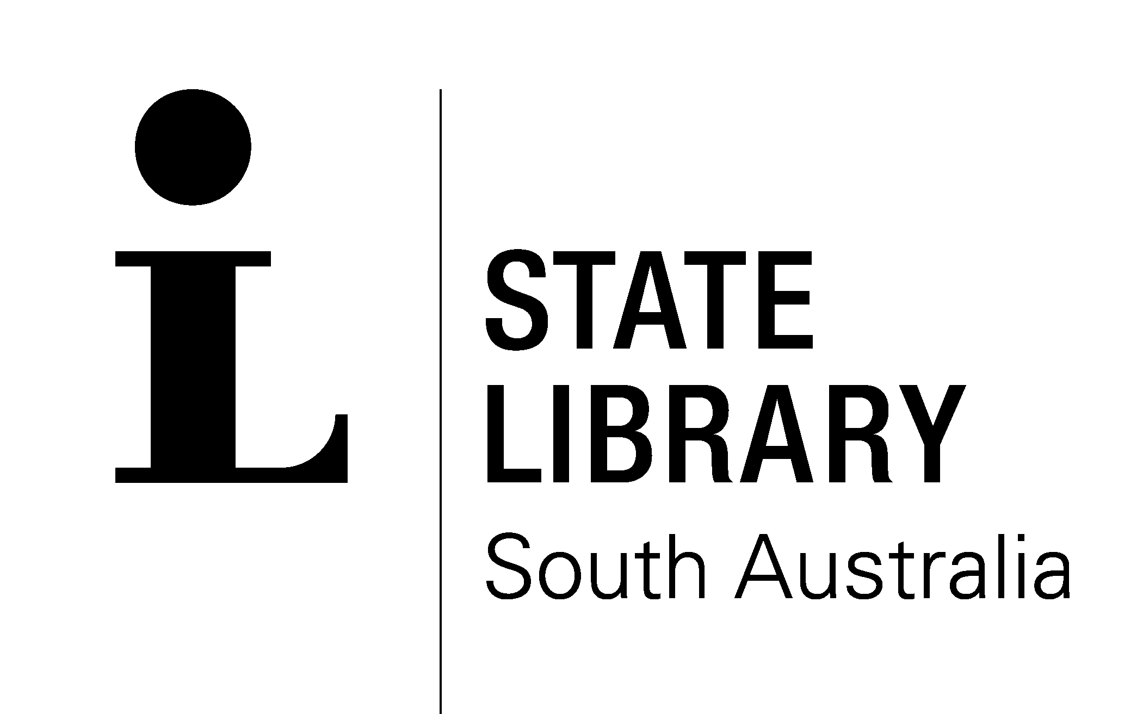

Essentials Tours!

The State Library will conduct some focussed “how to do” tours commencing weekly from late February.

What?…

Each tour is approximately forty-five minutes to an hour in duration and will cover three areas in the following sequence:

- Basic searching & locating of items in our catalogues and the open access collections.

- Navigating the retrievals from storage system of the State Library: initiating your requests, locating your requests, and understanding some restrictions on use and copying.

- The steps in printing and copying of materials: the Monitor payment credit system; printing from our computers, photocopiers & microfilms; and Copy Centre services.

Where?…

Meet at the Information Desk in the Spence Wing.

When?…

Every Monday commencing at 11.00 am & 4.00 pm sharp.

No booking required, however numbers are limited, so please be punctual!

